


Health & Wellness Update

June 2023

June National Health Observances: Men’s Health and National Safety Awareness Month
June’s Health Observance is Men’s Health and National Safety Awareness. Looking for educational information related to these topics? If so, check out the following UnitedHealthcare educational resources:


Heart disease in men Men’s preventive health tips
Testicular cancer Prostate cancer Back pain relief

Click here to learn more

United at Work Presentation of the Month Ergonomics and You


Click here for the Ergonomics and You education presentation where we will learn how the environment in which you work may directly impact your posture and risk for injury. This presentation will teach you about ergonomics and musculoskeletal disorders. Specifically, we will define the causes and review the signs and symptoms of musculoskeletal disorders. We will also discuss the risk factors in your work environment and provide possible solutions to workplace hazards.

Click here to learn more

Healthy tip flier of the month.

Ergonomics and You
Ergonomics is the science of designing the job to fit the worker, rather than physically forcing the
worker’s body to fit the job¹.

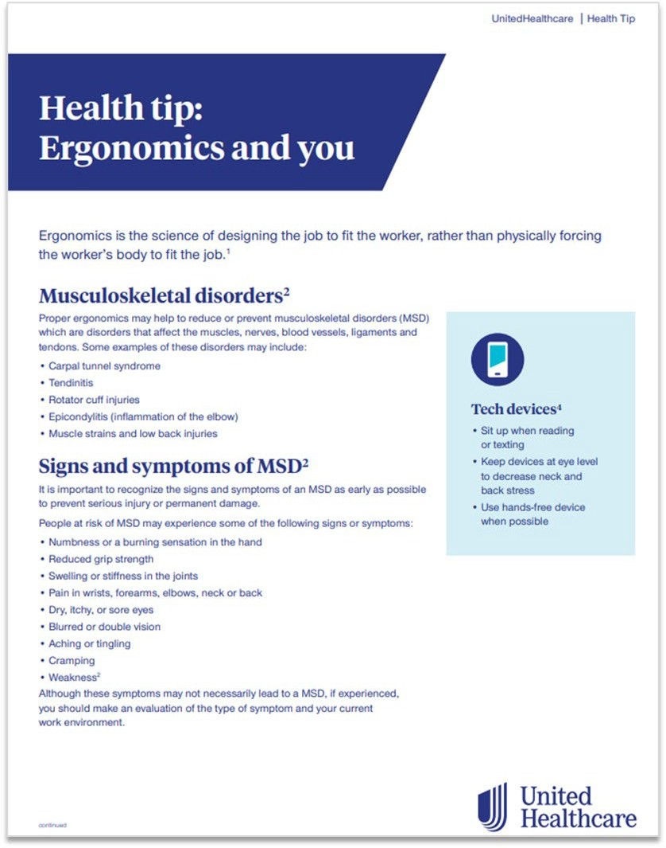
Click here for tips on ergonomics.
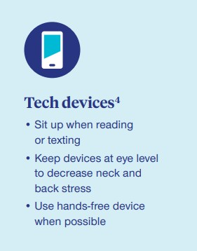

Sources:

1
UNC, Institutional Integrity and Risk Management,
Environment, Health and Safety, Ergonomics, https://ehs.unc.edu/workplace-safety/ergonomics/. Accessed August 2020

4
“10 tips for a healthy back”.
https://www.spine.org/KnowYourBack/Prevention/Lifestyle- Choices/10-Tips-for-a-Healthy-Back.

Click here to learn more tips

Research corner:

Children with Special Health Care Needs


Why does this matter?

Children with special needs (CSHCN) have or are at risk for chronic physical, developmental, behavioral or emotional conditions and require more health services than most children. Children with special health care needs may also:

- Require complex and long-term health services.

- Spend more on health care.

- Experience disparities in accessing care.

Roughly 19.4% of children in the United States – 14.1 million children –

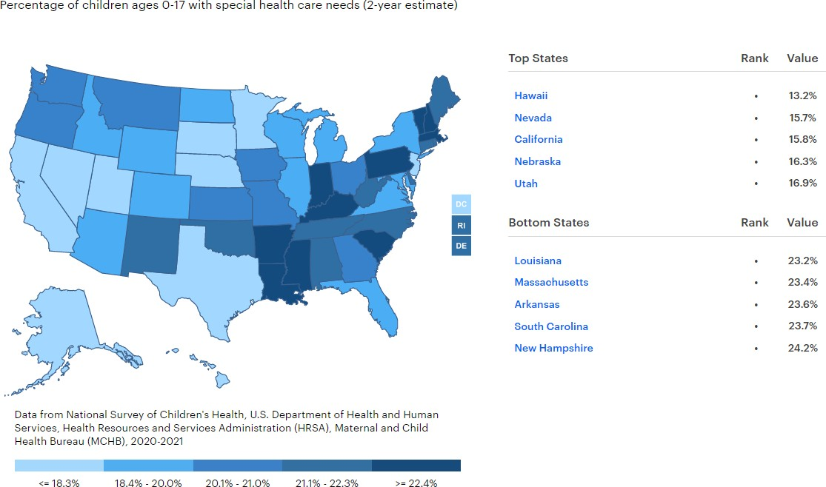
have special health care needs. In 2020, only 62.5% had adequate and continuous health insurance, including coverage for providers and services at a reasonable cost.

Children with Special Health Care Needs

U.S. Value: 19.5%

Top State: Hawaii: 13.2%

Bottom State: New Hampshire: 24.2%

Arizona/New Mexico/California: AZ 20.0% / NM 22.1% / CA 15.8%

Definition: Percentage of children ages 0-17 with special health care needs (2-year estimate)

Who are they?

Children and youth with special health care needs are defined as those who have or are at risk for a chronic physical, developmental, behavioral, or emotional condition and who also require health and related services of a type or amount beyond that required by children generally.

How many are there?

- Approximately 14.1 million children in the U.S. – Over 19% of all people under the age of 18 – have special health care needs.

- More than a fifth of U.S. households with children have at least one child with special needs.

Data Source & Year(s): National Survey of Children’s Health, U.S. Department of Health and Human Services, Health Resources and Services Administration (HRSA), Maternal and Child Health Bureau (MCHB), 2020-2021

Suggested Citation: America’s Health Rankings analysis of National Survey of Children’s Health, U.S. Department of Health and Human Services, Health Resources and Services Administration (HRSA), Maternal and Child Health Bureau (MCHB), United Health Foundation, AmericasHealthRankings.org, accessed 2023.

Click here to see how your state ranks



Supporting you with resources for COVID-19.

Our response to the coronavirus (COVID-19) is focused on helping you get access to the information and services you need. Below is a link to a library of frequently asked questions by category that will be continually updated as COVID-19 details evolve.
Click here to learn more

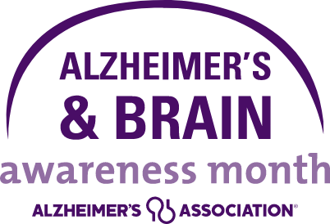
June is National Alzheimer’s & Brain Awareness Month

Worldwide, more than 55 million people are living with Alzheimer’s or another dementia.
Alzheimer’s is a type of dementia that affects memory, thinking and behavior. Symptoms eventually grow severe enough to interfere with daily tasks.

Understanding Alzheimer’s and dementia
Alzheimer’s is the most common cause of dementia, a general term for memory loss and other cognitive abilities serious enough to interfere with daily life. Alzheimer’s disease accounts for 60-80% of dementia cases.
Alzheimer’s is not a normal part of aging. The greatest known risk factor is increasing age, and the majority of people with Alzheimer’s are 65 and older. Alzheimer’s disease is considered to be younger-onset Alzheimer’s if it affects a person under 65. Younger-onset can also be referred to as early-onset Alzheimer’s. People with younger-onset Alzheimer’s can be in the early, middle or late stage of the disease.
Alzheimer’s worsens over time. Alzheimer’s is a progressive disease, where dementia symptoms gradually worsen over a number of years. In its early stages, memory loss is mild, but with late-stage Alzheimer’s, individuals lose the ability to carry on a conversation and respond to their environment. On average, a person with Alzheimer’s lives 4 to 8 years after diagnosis but can live as long as 20 years, depending on factors.
Alzheimer’s has no cure, but treatments demonstrate that removing beta-amyloid, one of the hallmarks of Alzheimer’s disease from the brain reduces cognitive and functional decline in people living with early Alzheimer’s. Other treatments can temporarily slow the worsening of dementia symptoms and improve quality of life for those with Alzheimer’s and their caregivers. Today, there is a worldwide effort underway to find better ways to treat the disease, delay its onset and prevent it from developing.

Symptoms of Alzheimer’s
The most common early symptom of Alzheimer’s is difficulty remembering newly learned information.
Just like the rest of our bodies, our brains change as we age. Most of us eventually notice some slowed thinking and occasional problems with remembering certain things. However, serious memory loss, confusion and other major changes in the way our minds work may be a sign that brain cells are failing.

People with memory loss or other possible signs of Alzheimer’s may find it hard to recognize they have a problem. Signs of dementia may be more obvious to family members or friends. Anyone experiencing dementia-like symptoms should see a doctor as soon as possible.

Source: www.alz.org/alzheimers-dementia/what-is-alzheimers
Click here to learn more

Rally Mission of the month.
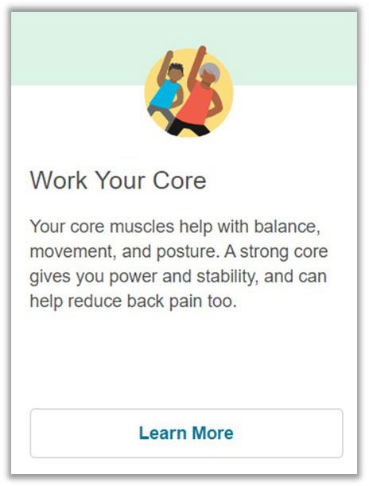
Work Your Core

Rally missions can help support members in taking small steps to live healthier lives. Consider adding this as your personal Rally Mission by logging on to your myuhc.com account or on your Rally app.

Rally is available at no additional cost to you, as part of your health plan benefits with UnitedHealthcare. Get started today at myuhc.com.

Click here to learn more

What’s on the menu?



Equipment
Creamy Cucumber Salad
This simple, four-ingredient Creamy Cucumber Salad is made with Greek yogurt instead of sour cream, along with fresh dill.

Swapping sour cream for full-fat yogurt, which has more protein, less fat, and is just as delicious. It’s a fast, fresh and easy side dish perfect for summertime parties, picnics, potlucks and quick weeknight meals.
Why You’ll Be Making Cucumber Salad All Summer

Easy: This summer salad takes less than 15 minutes to make with only four ingredients, including salt.

Healthy: Cucumbers have a high water content, making them low in calories and carbs. They are packed with vitamins and minerals, like vitamins C and K and potassium. Greek yogurt boosts the protein in this salad while adding calcium and probiotics.

Refreshing: Cucumbers are so refreshing on the dog days of summer, and this creamy cucumber salad is the best summer side to cool you off.

- Mandolin, optional but quicker to slice and makes even slices

Ingredients

- 2 medium cucumbers, peeled (8 ounces each)

- ½ cup Greek yogurt, full fat

- ¾ tsp kosher salt

- 1tbsp fresh dill

INSTRUCTIONS

  - Slice the cucumbers 1/8-inch thick with a mandolin, season with salt and combine with yogurt and fresh dill in a large bowl.

  - Refrigerate until ready to eat.

  - Transfer to a serving bowl topped with more fresh dill, for garnish.

Nutrition Information:
Serving: ¾ cup Yield: 4 Servings
Prep time: 10 mins, Cook time: 0 mins., Total time: 10 mins

Calories – 60 Carbohydrates – 7 g Protein – 5 g
Fat – 1.5 g

Saturated Fat – 1 g Sodium – 229.5 mg Fiber – 1 g
Sugar – 4 g Cholesterol – 7 mg

Source: www.skinnytaste.com/creamy-cucumber-salad/
Click here for the recipe

July Preview
Health Observance: Summer Safety
Health Tip Flier of the Month: Summertime Health
United at Work Presentation of the Month: Hydration and Healthier Beverages Rally Mission of the Month: Track your fluids


Insurance coverage provided by or through UnitedHealthcare Insurance Company or its affiliates. Administrative services provided by United HealthCare Services, Inc. or their affiliates. Health Plan coverage provided by or through UnitedHealthcare of AZ/NM, Inc.

