Dear Participant:

Since you participate in the Health Reimbursement Account (HRA), every dollar set aside in your HRA is available to save you money on out-of-pocket expenses such as deductibles, coinsurance and self-pays.

The Board of Trustees is now providing you with an easy way to access your HRA. Within two weeks, you will be receiving 2 Benny™ Cards at your home address for you and your family members to use. The Cards will arrive in a special envelope that looks like this-- so please don’t throw it out!

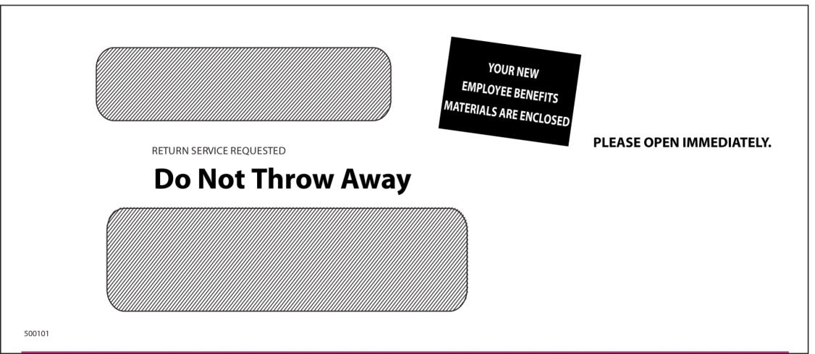I

Your Benny™ Card is loaded with the available balance of your HRA (less any amounts you have already spent) and is updated regularly. The Card is then used, instead of cash, to pay for qualified health care expenses such as:

- Covered prescription co-pays and deductibles • Health plan deductibles
- Orthodontics • Doctor and emergency room co-pays
- Coinsurance • Lasik surgery and eyeglasses
- Out-of-pocket dentist or other provider fees • Patient balance due
- Mail service and online prescriptions co-pays and deductibles

Simply swipe the Benny™ Card each time you incur a qualified health care expense at locations that accept MasterCard or Visa debit cards and the amount of your purchase will be deducted from your HRA – automatically. You can also fill in your Card number on bills you receive from providers to pay the amount you owe. It’s that easy!

Remember, the Card will not work at gas stations or restaurants—only at health care related providers.

It’s Important to Save Your Receipts!

Your Benny™ Card will definitely improve your cash flow. However, be aware that the IRS requires the Card only be used for eligible expenses. Most of the time, we can verify the eligibility of the expense automatically. Yet, there are instances when you’ll receive a letter/notification asking you to furnish an itemized receipt to verify the expense. When you receive such a request, make sure you submit the receipts as soon as possible to avoid having your Card suspended until receipts have been submitted and approved.

When might you receive such a letter? Some of the more common instances include:
- When the Card is used to pay a coinsurance bill from a provider (for amounts not covered by insurance) and the benefit plan data is not available
- When you or your dependents are not covered by your employer’s plan
- When ineligible items are purchased with your HRA-eligible items in a pharmacy, medical, dental or vision location
- When over-the-counter items are purchased from merchants other than our partners (e.g. Walgreens, drugstore.com)

What is an itemized receipt? An itemized receipt must include: merchant or provider name, services received or item purchased, date of service, and amount of the expense. Cancelled checks, handwritten receipts, card transaction receipts or previous balance receipts cannot be used to verify an expense. We suggest that you keep their itemized receipts in one place (perhaps using the “Save the Receipt” envelopes provided) so they’re readily available when you receive a request.

Using Your Card is as Easy as 1-2-3!

Look for additional information about how to use your new Benny™ Cards included with your card packet in the mail. We hope you enjoy this new exciting feature of your HRA!

For The Board of Trustees,
Pipefitters Local 636 Fringe Benefit Funds

